SCI 10 Weather Day 13 Ocean Currents & Their Effect on Weather
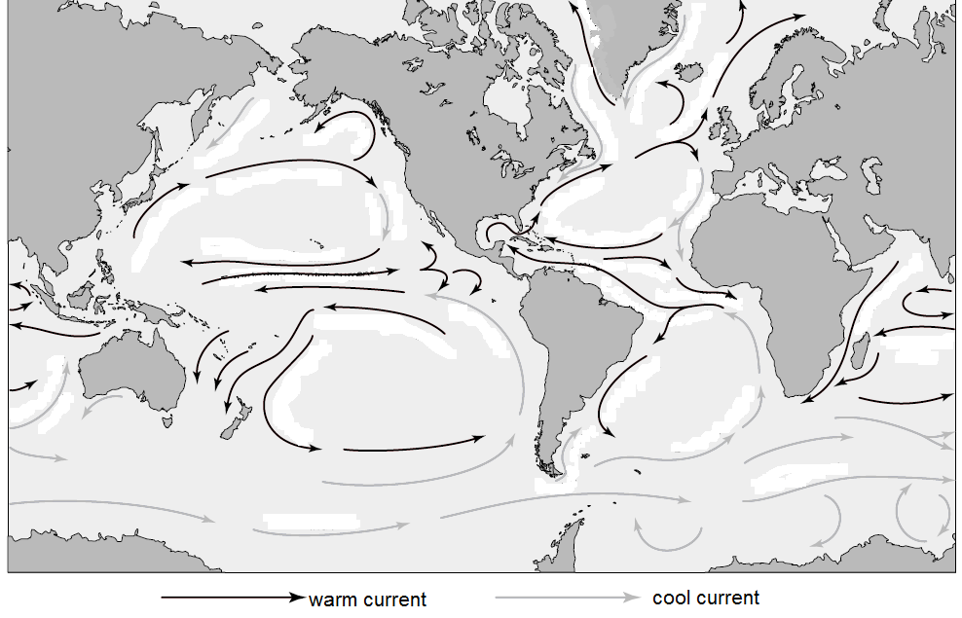
- What is the relationship between the temperature of an ocean current and its direction of current flow relative to the equator? Explain why this relationship exists.
- What is the general relationship between a current’s temperature and the side of the ocean on which that current flows?
- Along the east coast of a continent, what is the general relationship between a current’s temperature and the direction of its flow? What is the general relationship along the west coast of a continent?
- In what direction, clockwise of counter clockwise, do the major circulation patterns rotate in:
  - The Northern Hemisphere?
  - The Southern Hemisphere?
Why does each hemisphere have a different pattern?
- Trace the latitude lines for the equator and for latitudes 30°N, 30° S, 60° N, and 60° N. Determine and draw the prevailing winds in each of these four regions created by the latitude lines. Compare the prevailing winds and ocean currents in the Northern Hemisphere. How are the two related? What causes the deflection of the wind and ocean currents?
- Locate Nova Scotia on your map. Name one warms current and one cold current that are likely to affect NS.
- How do you think the temperature of the ocean current could affect weather on the coast?
  - A cool current would …
  - A warm current would …
- How do you think ocean currents affect sailing ships and weather systems/storms?

