SCI 10 Physics Distance and Displacement Comp Check Name: ______________
- Warren starts 2.6 km [N] of his friend Kevin's house. He picks up Kevin and they both walk to a party at Joe’s house, 1.35 km [S] of Kevin’s house.
a) What distance did Warren walk?

b) What is Warren's displacement?

Use the following information and the diagram to answer the next 2 questions.
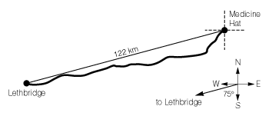
Highway signs indicate the distance from Medicine Hat to Lethbridge is 186 km. The route and the direction of Lethbridge from Medicine Hat are marked on the diagram.
- What is the best way to write the distance along the highway from Medicine Hat to Lethbridge?
  - d = 186 km b. c. d.

- What is the best way to write the displacement from Medicine Hat to Lethbridge?
a. | 122 km | c. | 122 km SW
b. | 186 km | d. | 186 km SW

SCI 10 Physics Distance and Displacement Comp Check Name: ______________
- Warren starts 2.6 km [N] of his friend Kevin's house. He picks up Kevin and they both walk to a party at Joe’s house, 1.35 km [S] of Kevin’s house.
a) What distance did Warren walk?

b) What is Warren's displacement?

Use the following information and the diagram to answer the next 2 questions.
Highway signs indicate the distance from Medicine Hat to Lethbridge is 186 km. The route and the direction of Lethbridge from Medicine Hat are marked on the diagram.
- What is the best way to write the distance along the highway from Medicine Hat to Lethbridge?
  - d = 186 km b. c. d.

- What is the best way to write the displacement from Medicine Hat to Lethbridge?
a. | 122 km | c. | 122 km SW
b. | 186 km | d. | 186 km SW

