Rules for Graphing
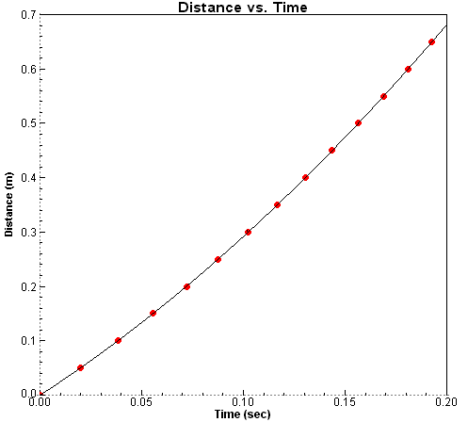
- Independent variable goes on the x-axis (bottom)
- Dependent variable goes on the y-axis
- Always label your axis so we know what they represent
- Add a title to your graph
- Draw a straight line

Calculating Slope

- Slope is often referred to as “rise over run”.
- Rise is the change in y, or Δy.
- Run is the change in x, or Δx. Therefore, “rise over run” means Δy
Δx
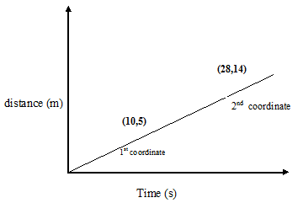

The coordinates on the graph above can be used to calculate the slope of the line.

Slope = rise = Δy = y_{f} – y_{i} = (14 m – 5 m) = 9 m = 0.5 m
run Δx x_{f} – x_{i} (28 s – 10 s) 18 s s

LINE of BEST FIT AND SLOPE

PRACTICE A - Use the data below to plot Colleen’s bike drive from home to school.
- Draw the line of best fit *not connect-the-dots
- Calculate slope using the line you drew. Include your Units!
- What is the meaning of this calculation?
- Interpolate: How far did Colleen travel in 22 seconds? Use your graph to find out.
- Extrapolate: If Colleen decides not to go to school and drives right by SHS, how far do you think she would travel in 1 minute if she biked at the same rate?
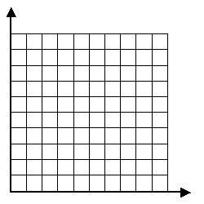
Time (s) | Distance (m)
0 | 0
5 | 60
10 | 105
15 | 140
20 | 210
25 | 260
30 | 290
35 | 350
40 | 425
45 | 475

PRACTICE B – Use the graph below of a jogger’s movement to answer the questions that follow.
- What is the slope between 2.0s and 4.0s? What does this represent?

- 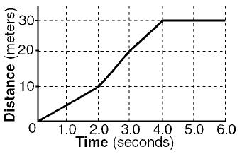 What is the slope between 4.0s and 6.0s? What does this mean?

