SCI 10 Physics Practice Problems - Speed & Velocity
Be sure to show all your work while doing these questions! Don’t forget units!

- a) What is the speed of a car that travels 150 km in 3.00 h?

- The car is driving north; what is its velocity?

- Ben skates towards the hockey puck and shoots at the net. The puck travels 7 m into the net in 0.5 s. Calculate the speed of Ben’s shot.

- What distance will a car traveling 65.0 km/h travel in 3.00 hours?

- What distance will be traveled if you are going 120km/h for 30 min?

- How long will it take to go 150 km traveling at 50 km/h?

- A car travels 240 km in 2.0 hrs and a sprinter travels a 100.0 m in 9.50 s. Which is traveling faster and by how much?

- Jimmy views football games from under the bleachers. He frequently paces back and forth to get the best views. The diagram below shows several of Jimmy’s positions and times. At each marked position, Jimmy makes a "U-turn" and moves in the opposite direction. In other words, he moves from position A to B to C to D.
- What is Jimmy’s average speed?
- What is Jimmy’s average velocity?

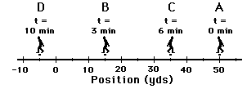

- The rugby team runs around the block twice for a morning training run, approximately 4 km, it takes the first group 25 minutes. What was their average speed (in km/h)? What was their total displacement? What was their average velocity?

- Dave Stieb of the Toronto Blue Jays threw a fastball that was “clocked” by a radar gun at 138km/hr as it crossed the plate. On the same pitch, the pitching coach used a stopwatch to find the time for the ball to travel from the pitcher to home plate, a distance of 20m. The time was 0.50s. Calculate the speed of the ball (in km/h). Indicate which is the instantaneous speed and which is the average speed.

- The following data was collected for a car. Sketch the graph for this data. Then, calculate the average velocity for each interval indicated.
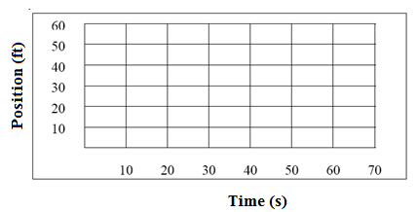
Time (s) | Position (ft)
0 | 0.0
10 | + 15.0
20 | + 30.0
30 | + 20.0
40 | + 15.0
50 | + 30.0
60 | + 50.0

Calculate the average velocity for each time interval below.

  - 0 to 20 seconds

  - 20 to 40 seconds

  - 40 to 50 seconds

  - 50 to 60 seconds

